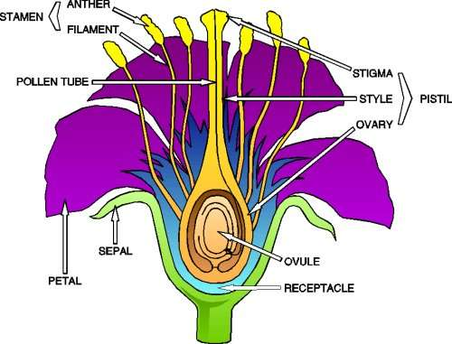
- Complete these sentences:
pollen flowers petals fruits stamen sepals pistil ovules

The reproductive organs of the plants are the ………….They have two parts: the reproductive and the protective. The reproductive parts of a flower are the ……………. and the …………… The protective parts of the flower are the …………… which make up the calyx and the …………… which attract insects and make up the corolla. The ………. … are inside the ovary. When the ovules come into contact with the ………….. produced in the stamen they turn into seeds. The ovaries turn into……….

- Which is the male part of a flowering plant?
- Which is the female part of a flower?
- Which one is the odd one out? a)Stigma b)Anther c)Style d)Ovary.
- What are the petals for?
- What is the calyx for?
- What is pollination?
- A pollen nucleus fusing with an ovule.
- Pollen sticking to the stigma.
- A pollen tube growing.
- An ovary turning into fruit.

- What do the ovaries and the ovules become after fertilisation?

- Match each types of pollination with the characteristics of the flowers.

Insect pollination | Flowers have brightly coloured petals
Insect pollination | No scent (perfume)
Insect pollination | No nectar  Stamens are hidden inside the flower
Wind pollination | Scented flowers
Wind pollination | They contain sugary nectar inside them
Wind pollination | They produce more pollen  Stamens are very long

