THE DIGESTIVE SYSTEM. Write the name of each organ and its function in the right place.
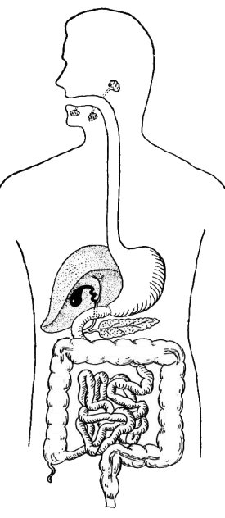 | ORGAN | FUNCTION

Large intestine. Food is moved from the throat to the stomach. Small intestine. Anus. Food is chewed and mixed with saliva. Water absorption. Liver and pancreas. Oesophagus. Elimination of undigested products. Food is mixed with gastric juices. Stomach. Mouth (tongue and teeth). Digestion and absorption of nutrients. They produce bile and pancreatic juice that break down the food.

THE DIGESTIVE SYSTEM. Write the name of each organ and its function in the right place.
 | ORGAN | FUNCTION

Large intestine. Food is moved from the throat to the stomach. Small intestine. Anus. Food is chewed and mixed with saliva. Water absorption. Liver and pancreas. Oesophagus. Elimination of undigested products. Food is mixed with gastric juices. Stomach. Mouth (tongue and teeth). Digestion and absorption of nutrients. They produce bile and pancreatic juice that break down the food.

