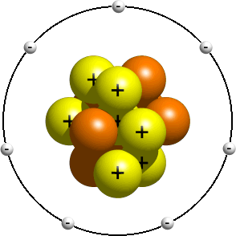
- Label this picture.

- True or false:

  - Atoms of gold are the same as atoms of oxygen.
  - Compounds are formed by two or more elements.
  - The horizontal rows in the periodic table are called periods.
  - The vertical columns in the periodic table are called groups.
  - The element carbon can be represented by the symbol C
  - The element silicon can be represented by the symbol S.
  - Protons have a negative charge.
  - Neutrons and protons are in the nucleus of a carbon atom.

- Find the right word for these definitions:

  - The central part of an atom:
  - A very small particle with a positive charge.
  - A very small particle almost without mass.
  - A very small particle with no charge.
  - The place where the protons are.
  - A very small particle with a negative charge.

- Draw the structure of an atom made up of 9 electrons, 9 protons and 10 neutrons. Look for the name of this element in the periodic table.

- Complete the following table:

Elemento | Número atómico | Masa atómica | Número de electrones | Número de protones | Número de neutrones
Molibdeno: Mo | 42 | 96 | 42 | 42 | 54
Cloro: Cl |  |  | 17 | 17 | 18
Estroncio: Sr |  |  |  | 38 | 50
Cinc: Zn | 30 | 65 | 30 | 30 | 35
Uranio: U | 92 | 238
Hierro: Fe | 26 |  |  |  | 30
Aluminio: Al |  |  | 13 |  | 14

