- You can ask: How many states of matter are there? (Solid, liquid, gas). You can dictate the full sentence: The three states of matter are solid, liquid and gas. Then, you can say/write the names of different substances and they have to say their states: wood, oxygen, stone, carbon dioxide, juice, air, smoke, milk, wine, perfume (liquid and gas), book, iron...
- After this, we are talking about the shape of solid, liquid a gaseous objects. Remind them the meaning of shape. Does their shape change? Solids have always the same shape, a fixed shape, but liquids and gases change, they have the shape of the receptacle they are in. The answer (yes/no) can be written in the first column of the chart. Then, you are asking a similar question: Does their volumen change? Just volume of gases change (the teacher can show a balloon and a syringe to explain this and explain something about particles).

States | Does their shape change? | Does their volume change? | Particles
Solid

Liquid

Gas

- Tell them we are going to explain the CHANGES OF STATE. Remember a substance change when we HEAT or COOL it (Write every word in capital letters on the board and explain their meanings, please).
  - WHAT HAPPENS when we cool liquid water? It BECOMES solid (ice)
  - What happens when we heat water? It becomes gas (water vapour).
  - What happens when we cool a gas? It becomes liquid.
  - What happens when we heat a solid?
  - And so on.
- Then you can show the names of the different changes of state. Practise the pronunciation and wait two minutes for them to copy this graph:
GAS
Boiling Condensing
LIQUID
Melting Freezing
SOLID
- Then you can ask some questions to check if they have understood the previous words:
  - What's the name of the change from solid to liquid?
  - And from gas to liquid?
  - What happens to the liquid water if it is warmed up?
  - And if you cool it? How is called that process?
  - What is the boiling?
  - What is the condensation?
  - Etc
- Eventually I hand out a worksheet to review this lesson.
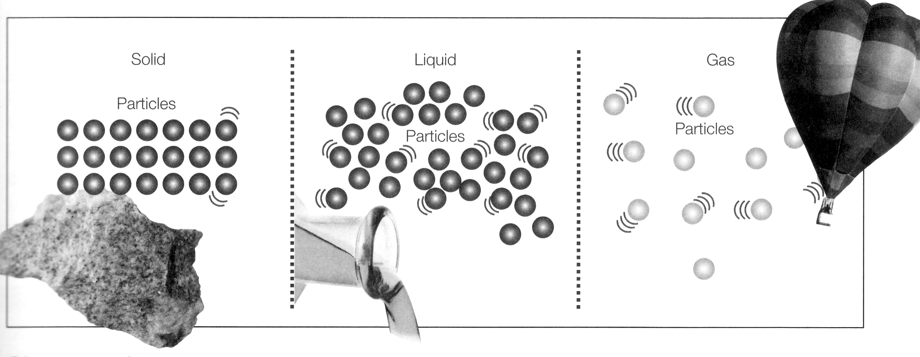

1.Complete the phrases with the following words:
gaseous * liquid * constant * freedom * close * containers * volume * shape
- The solid state has a definite ………………. and a constant …………… The particles are very …………… together.
- In the ……………… state, the particles which make up the matter have great ………….. movement.
- Liquids do not have a constant shape. They take the shape of their ………………
- Gases do not have a ………………….. shape or volume.
- In the ………………. state, the links between particles are weaker than in the solid state, but the volume is constant.

2.True or false? Rewrite the false sentences correctly.

The change from solid state to the liquid state is called solidification.
……………………………………………………………………….
If a gas cools, it condenses.
……………………………………………………………………….
Melting is when a liquid turns into a gas.
……………………………………………………………………….
Water boiling point is 100 degrees Celsius.
……………………………………………………………………….

