QUESTIONS AND ANSWERS ABOUT MEASURING AND WEIGHING
- How long is the street? The street is 150 m long.
- How wide is the window? The window is 120 cm wide.
- How high is the chair? The chair is 1m high.
- How tall is the player? He is 2 m tall. (Tall is used for people and high for objects).
- How far (away) is the door from the window? It is a metre away.
- How warm is it in the bathroom? It is 16 degrees Celsius.
- How heavy is the suitcase? The suitcase is 12 kg or The suitcase weighs 12 kg. (Note: you don’t say heavy in the answer.)
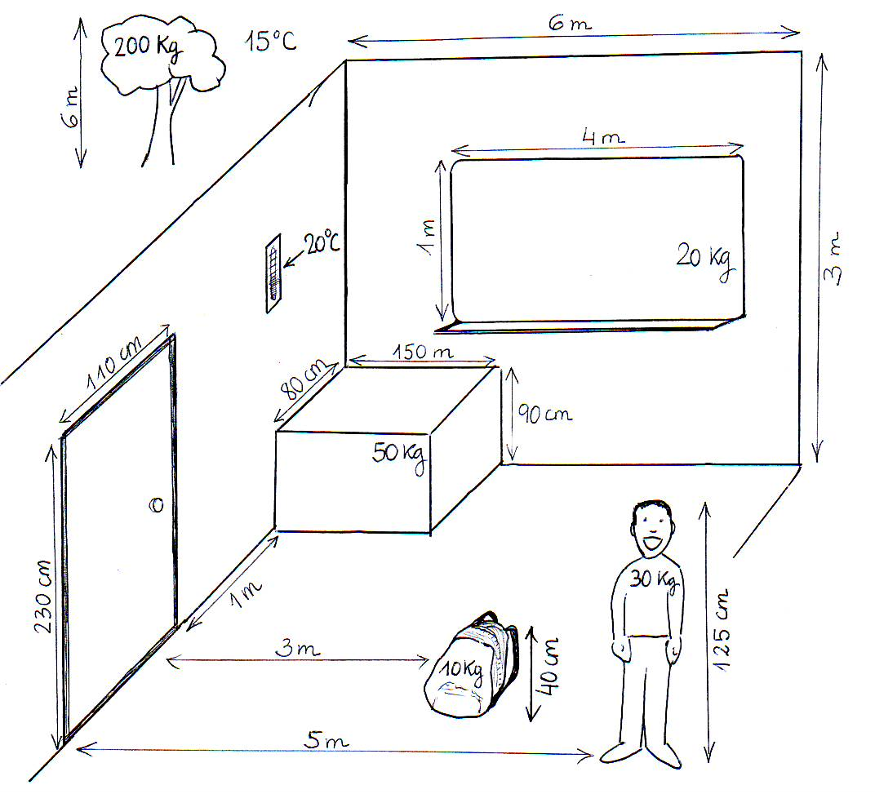
- How wide is the table?
- How high is the ceiling?
- How heavy is the bag?
- How high is the door?
- How high is the tree?
- How far is the bag from the door?
- How heavy is the board?
- How wide is the board?
- How heavy is the boy?
- How heavy is the tree?
- How warm is it outside?
- Ask about the bag.
- Ask about the table.
- Ask about the door.
- Ask about temperature.
- A question about the length of something.
- Ask about the distance between the boy and the door.

